Rwanda

## Respect for rule of law (ROL) data

The data set shows the data on the respect of the rule of law for the country.

## # A tibble: 19 x 5  
## country iso3c date ruleOfLaw ruleOfLawCategory4   
## <chr> <chr> <dbl> <dbl> <chr>   
## 1 Rwanda RWA 1996 -1.50 ROL highly disrespected   
## 2 Rwanda RWA 1998 -1.35 ROL highly disrespected   
## 3 Rwanda RWA 2000 -1.22 ROL highly disrespected   
## 4 Rwanda RWA 2002 -0.856 ROL moderately disrespected  
## 5 Rwanda RWA 2003 -0.804 ROL moderately disrespected  
## 6 Rwanda RWA 2004 -0.819 ROL moderately disrespected  
## 7 Rwanda RWA 2005 -0.917 ROL moderately disrespected  
## 8 Rwanda RWA 2006 -0.675 ROL moderately disrespected  
## 9 Rwanda RWA 2007 -0.577 ROL moderately disrespected  
## 10 Rwanda RWA 2008 -0.477 ROL moderately disrespected  
## 11 Rwanda RWA 2009 -0.501 ROL moderately disrespected  
## 12 Rwanda RWA 2010 -0.331 ROL moderately disrespected  
## 13 Rwanda RWA 2011 -0.314 ROL moderately disrespected  
## 14 Rwanda RWA 2012 -0.272 ROL moderately disrespected  
## 15 Rwanda RWA 2013 -0.155 ROL moderately disrespected  
## 16 Rwanda RWA 2014 0.0569 ROL moderately respected   
## 17 Rwanda RWA 2015 0.0504 ROL moderately respected   
## 18 Rwanda RWA 2016 0.102 ROL moderately respected   
## 19 Rwanda RWA 2017 0.129 ROL moderately respected

## Respect for rule of law (ROL) trend

The plot shows the trend of the respect for the rule of law for the country.

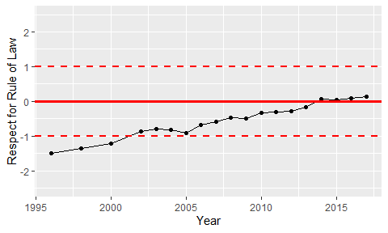

Trend of the Respect for the Rule of Law